**Day-7:**

**Live Deployment and Post-Launch Practices**

**“Food restaurant”**

1. **Production Deployment**

* **Environment Setup:**
* Configure production environment variables securely.
* All sensitive data (e.g., API keys, database credentials) is encrypted and stored **securely.**
* **Secure Hosting:**
* Use reliable hosting platforms like Vercel.
* Vercel is provide HTTPS for all traƯic using SSL certificates.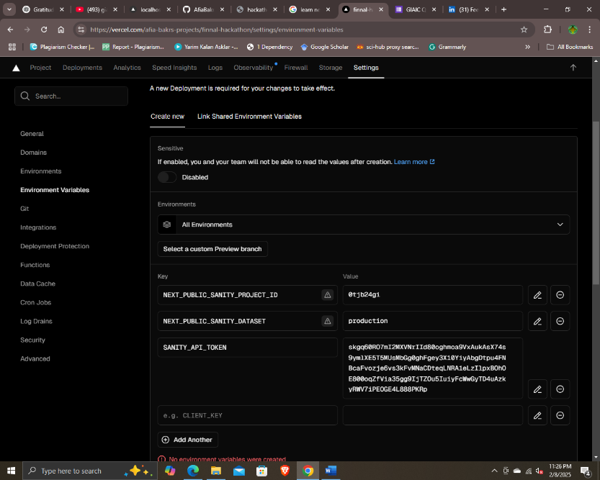

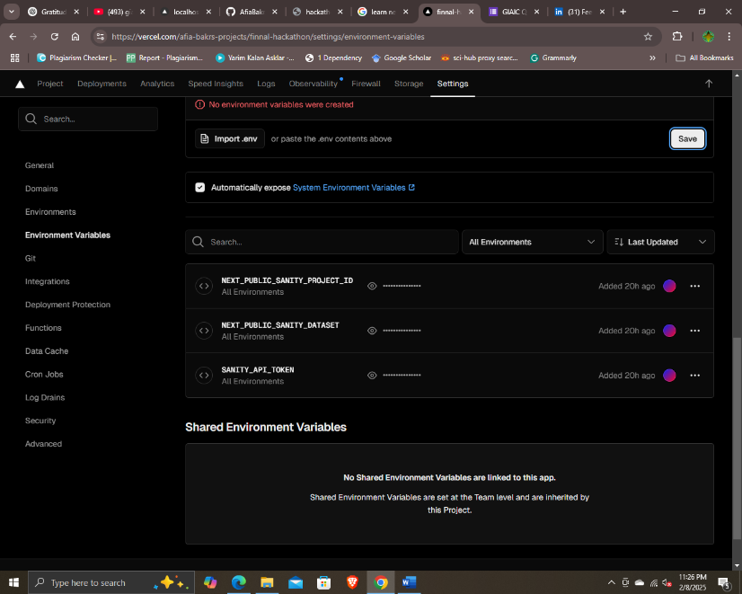

* **Codebase Management:**
* Keep the production repository public to show code for Faculties.
* Document step of deployment process.

**Steps:**

1. Open the Vecel account.
2. Go on account dashboard.
3. Click on ‘Add New’ DropDown Button held top right.
4. Click on ‘Project’.
5. Click on ‘Import’ button in left card of ‘Import Git Repository’.
6. Check the Project Name if want change.
7. Click on ‘Build and Output setting’ and enable Install command and write
8. ‘ npm install –force’.
9. Click on ‘Environment Variable’ , go to project code editor open ‘.env.local’ file
10. And copy of productid, database and token and past in ‘Environment Variable’.
11. Click on’ Deploy’ button.
12. Wait for deployment Congratulation popup or Deployment fail with build error.
13. If get Congratulation massage then CONGRATULATION
14. If the Error massage read carefully each line. It provides clearly path of each file and line number with column where Vercel not compile them.
15. Go project code editor resolve the deducted error push again the file in existing GitHup Repo and do again all process.
16. I want to Delete ‘Failed Deployment project’ go to right side three dots on project click on dots and go to setting.
17. Scroll down screen and in last of bottom find ‘Delete’ button follow the instruction and delete ‘Failed Deployment Project’.
18. **Pitch Deck Link:**

<https://drive.google.com/drive/folders/1yoGXxJG6HCb_gE-_cyK7vDMD2e1pNTGJ>

1. **Resume Link:**

[**https://hackathon-01-milestone-1-2.vercel.app/**](https://hackathon-01-milestone-1-2.vercel.app/)

1. **Profile Link**

<https://afia-portfolio.vercel.app/>

1. **Hackathon GitHub Link**

https://github.com/AfiaBakr/finnal-hackathon.git

1. **Hackathon Vercel Link**

https://finnal-hackathon.vercel.app/

1. **Checklist for Day 7:**
   * Deployment Checklist: • ✔
   * Security Checklist: • ✔
   * Post Go Live Checklist: • ✔
   * Business Pitch Deck: • ✔
   * Resume PDF: • ✔